Using the Binary Search Algorithm and trace table examples at the end of this document, complete the trace tables below for the Color Array. Upload this document to github and submit the link to your repository to the dropbox.

1st search: violet
First | Last | Middle | Comparison
0 | 10 | 5 | Violet > indigo
6 | 10 | 8 | Violet > red
9 | 10 | 9 | Violet = violet

2nd search: green
First | Last | Middle | Comparison
0 | 10 | 5 | Green < indigo
0 | 4 | 3 | Green > chanteuse
3 | 4 | 3 | Green > dark brown
4 | 4 | 4 | Green = green

3rd search: yellow
First | Last | Middle | Comparison
0 | 10 | 5 | Yellow > indigo
6 | 10 | 8 | Yellow > red
9 | 10 | 9 | Yellow > violet
10 | 10 | 10 | Yellow = yellow

Color array:
aqua | [0]
brown | [1]
chartreuse | [2]
dark brown | [3]
green | [4]
indigo | [5]
lavender | [6]
magenta | [7]
red | [8]
violet | [9]
yellow | [10]

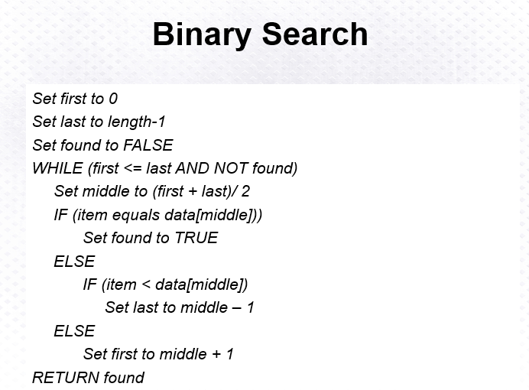
Above: Binary Search Algorithm
